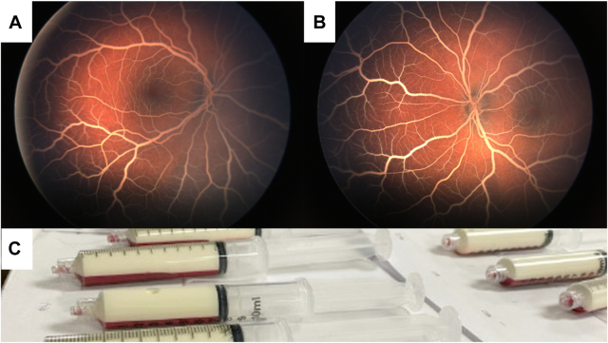

A 40-day-old female infant presented with 2 weeks of poor feeding, melena, and rectal bleeding. Examination revealed bilateral severelipemia retinalis, characterized by bright white retinal vessels over a “salmon-colored” fundus (A, B). Triglyceride levels were extremelyelevated (437.05 mmol, reference range 1.12 mmol)(C). Based on the provided images and clinical description please make an ophthalmic diagnosis for this patient. And output the diagnostic conclusions only.

**Lipemia retinalis**